INSTRUMENT CLEANING
EVERYONE:
● 2 sharpened pencils​ in case or binder. (Attached with a string is a great way to keep track of it!)
● Clean out case clutter.
● Put current schedule ​in binder. Throw out old schedules.
● Enter your new lessons into Google Calendar​ with reminders.
● Binder order​: put things where they go!
● Vacuum​ case.
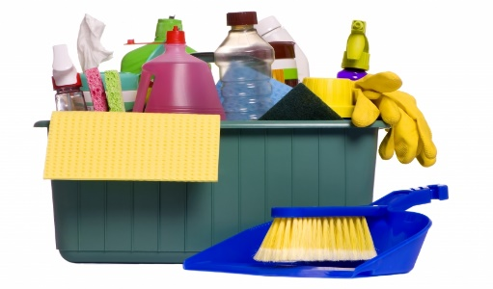
WOODWINDS:
1. Throw ​out old reeds that are broken or unusable.
2. Run cleaning cloth​ through inside of instrument twice the opposite way.
3. Wipe contact points ​(where it goes together) of the instrument with a cloth, cleaning off any build up.
Use a Q-tip to get the built up cork grease and dust from the inside of the joint connections.
4. Use Q-tip to clean tone holes​ on clarinet, bassoon, oboe. May need a pin to clean oboe tone hole.
5. Dust ​under posts and around springs with Q-tips. Be careful not to unhook springs!
6. Dip a Q-tip in rubbing alcohol, and clean any metal places​ on your instrument. Do NOT get it on the
pads.
7. Clarinets/saxes ONLY: Put mouthpiece (not ligature) in a bucket of soapy, lukewarm water. (NOT hot.
They can melt.) Using a mouthpiece brush, scrub the inside​ and outside of the mouthpiece. Remove
any remaining calcium build-up with vinegar on a Q-tip.​ Rinse in clear water. Dry with a soft cloth.
8. Polish ​your instrument with a soft cloth. Flutes--this can really make your instrument shine!
BRASS:
1. Lay out a towel​ and fill a bucket a​ bout halfway full of warm water. Add a small squirt of dishwashing
liquid. (At home, fill your bathtub with a few inches of water, and lay a towel at the bottom of the tub.
Add a squirt of soap.) You don’t want a lot--bubbles are just excess. The soap will do the work in
solution.
2. Take apart ​your instrument, being careful to do it gently, and lay them on the towel. Start with your
valves so the pressure is released in the instrument. If you have trouble, ask Mrs. B for help. If your
valves aren’t numbered, make sure to lay them in order so they don’t get mixed up.
3. Wash ​each small part in your bucket using the brushes in the cleaning kit. Scrub out all the nooks and
crannies! Long snake is for thinner tubes; wide brush is for the valves; cone shaped brush is for the
mouthpiece.
4. Put a drop of soap on the end of your snake​, and scrub it through all the tubes of your instrument. If
you’re at home, you can put the parts and the body in the tub and let them soak for about 30 minutes
first. This will help loosen anything inside.
5. Rinse​ all the parts and the main body of your instrument with clear water. (see other side)
6. Dry​ all the parts, then re-grease the slides with a little tiny bit of slide grease or Vaseline. Use a
molecule thin layer! Too much grease will make them stick and makes a mess. Re-oil your valves, and
reassemble ​your instrument. Make sure Valve #1 goes on the side toward your mouthpiece, #2 is in
the middle, and #3 is the furthest from your mouth. Valves should click in.
7. Polish​ your instrument with a soft cloth.
8. If you have been sick, you can boil the mouthpiece in water to make sure it is clean (Brass ONLY.
Clarinets and saxes DO NOT do this or you will have mouthpiece soup and a wrecked pot.)

